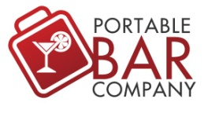
3990 Old Town Ave. A-100
San Diego, CA 92110

Maintenance and Care Guide
- Do not leave bar uncovered in a harsh environment and/or exposed to the elements.

- After each use, cover bar, or break it down, clean it and store in a dry place.

- Laminated panels and counters should be dried if they become wet. Laminated panels should also be covered from direct sunlight.

- When transporting the bar, be mindful of the acrylic panels and remove them from the frame of the bar if needed.

- Check powder coating regularly for any scratches or dings which may compromise the bar’s weather resistance. If you find a scratch or ding, touch of paint should be used to cover the exposed steel.

- When pushing the bar over a distance, it should not be stocked. When the bar is folded, push it from the end and not the side to keep from tipping the bar over.

- Keep two hands on the bars when pushing them to help with its stability going over uneven surfaces. For the Professional Bar it is recommended to use two people to move the bar when folded.

- When transporting or breaking down the bar, be mindful of the LED strips and disconnect the appropriate cables and connectors (if applicable)

- When running your LED system, make sure that the battery is not being used while the charger is plugged into on outlet. Use only one power source at a time.

- Do not leave your battery charged for more than 12 hours at a time.

